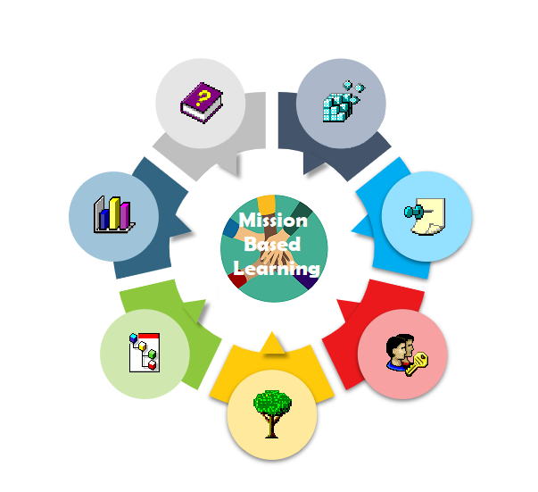

THE MISSION BASED LEARNING THEORETICAL CONTRIBUTION
TO THE EU OPEN SCHOOLING AGENDA

Research paper

WwEU

All photos by the project and WwEU

CONTENT

INTRODUCING THE PROJECT | 4
PART 1 - THE FRAME  The new generations  What about teachers and education?  Open schooling as re-thinking learning or as “modernisation” and entertainment? | 5  6  7
PART 2 - MAKING A REALITY THE VARIOUS FORMS OF OPEN SCHOOLING: THE NATURE OF MISSION BASED LEARNING  The key principles of open schooling and Mission Based Learning that make the young students prepared for a life in the 21st century  Impact of Mission Based Learning  What is not a mission | 10  12  16  16
PART 3 - DRIVING THE CHANGE  The reality  Schools and students as drivers of change  How this could happen | 17  19  20  22
PART 4 - THE COMMUNITY IN MISSION BASED LEARNING SCENARIOS | 24
PART 5 - POLICY SUPPORT AT EUROPEAN LEVEL  Joining forces  Recommendations for research and practical experimentation | 28  30  31
THE PROJECT SUPPORT | 33

This paper is based on almost three years of practical experimentation with the participation of five secondary schools, teachers and students, three knowledge partners and one quality assurance partner from different European countries.

The reason for this paper is the need for more collaboration between European initiatives to deliver qualified and practically useful guidance and support to schools to be engaged in educational innovation such as open schooling.

The paper deals with not only the open schooling innovation called by the European Commission, but unlike most Erasmus+ projects it elaborates and present key lessons learned and innovation recommendations to European level research and programming communities.

The lessons learned are based on dialogues with the participants along with the project and other Erasmus+ projects.

Key messages, unedited and authentic, from the participants are inserted.

Despite its theoretical nature, the language of the paper is not academic and richly illustrated to make the content accessible and attractive to large audiences.

Rich examples of the project experience can be found in the project website.

The MISSION BASED LEARNING project 2019-23 is funded by the European Commission Erasmus+ program

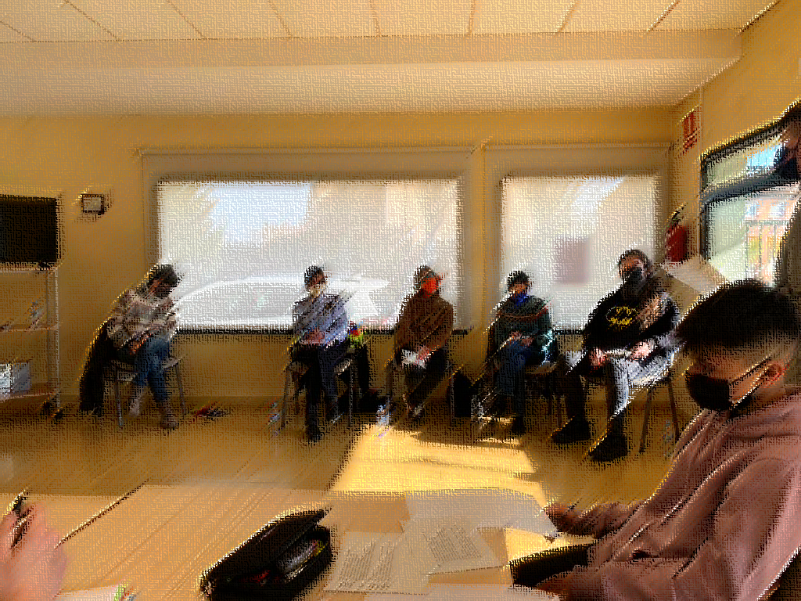

INTRODUCING THE PROJECT

Most important, it’s an education that creates adults – future citizens – who already have experience, from their education, in finding and implementing real SOLUTIONS TO REAL PROBLEMS. This is something that our current education not only does not do, but doesn’t even try to do.
Marc Prensky, “Education to Better their World – Unleashing the power of 21st century kids”, 2016

As documented by leading educational research and clearly stated by the EU Commission, EU’s education systems need to change dramatically and fundamentally.

The education we offer the new generations is not fit to give them the competences, skills and capacity to live, learn and work in the globalised 21st century. The world that the new generations grow up in is above all characterized by constant change, unpredictable direction and serious local and global threats. At the same time, and even more importantly, the new generations of students are dramatically different from former generations: the young people think, live and learn in fundamentally different ways that the older generations.

Mission Based Learning is an open schooling model, based on, but going further than the key principles of open schooling. The new learning approach is named Mission Based Learning, and it is based on 10 years of educational innovation experimentation.

The project sets out to test the qualities of Mission Based Learning through thorough experiments in secondary schools from different countries. From this experimentation, it delivers useful and practice-based guidance to teachers and schools in the process of taking action to change traditional classroom teaching or to integrate alternative learning activities into normal school life.

Mission Based Learning builds on two decades of educational innovation experimentation but takes innovation much further. This project allows the young students to learn from real-life engagement, from taking change action and from accomplishing important missions or projects with relevance to the students as well as the community.
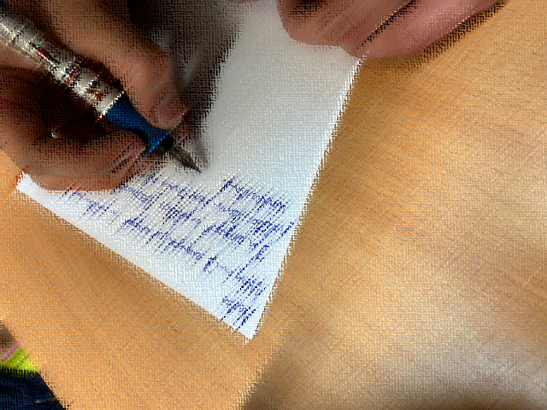

PART 1 - THE FRAME
The new generations

Because the capabilities of our present and future kids are now so different, the education that we have been universally offering them throughout the world is no longer appropriate for the times in which they and their posterity will live. To succeed in the future, todays and tomorrow’s young people require a different kind of start in the world – a different kind primary and secondary education than the world now offers them.
Marc Prensky, “Education to Better their World – Unleashing the power of 21st century kids”, 2016

In the 21st century, so many of our old assumptions and strongly held ideas have been turned around—and so many more upheavals are on the way—that it is clearly a different place in which our kids are growing up. Two-thirds of the people on the planet have a cell phone. A new virtual (i.e., online) world has emerged out of the ether and become the focus of many of our kids ‘attention.

Engineers are putting a trillion transistors on a single computer chip. Scientists are manipulating individual atoms to make nano-scale machines that we cannot even see. The world volume of information will soon be doubling every few hours. No longer do TV game shows put you in an isolation booth to prove no one is helping you; they encourage you to phone a friend or poll the audience.
It is inevitable, in such an environment, that change would finally come to our young people ‘education as well, and it has.
Our young people are rapidly changing their relations to “education”, “learning” and “careering”.
Not according to some Master Plan; it just happens.
Globalization, digitalization and new psychological and social patterns are the whys.
A giant cultural revolution at all levels: individual, collective, societal.
And moving so fast that the institutional world is left behind, desperately trying to adjust or catch up. Which it cannot, of course.
When the institutional world has taken a new step, the young people are long gone.

The new young people are different from us, they have other forms of identities, they live in the world in other ways, and the meaning of things is changing.
The new young people learn and work differently from us.

Because this, the European Commission as well as considerable practical experience clearly conclude that the new generations of young students are fundamentally different from earlier generations.

They learn, think, live and work in fundamentally different ways and the traditional education system and paradigms do not work well for these students.

New young generations will be constantly and exponentially changing and this is why static and fixed and stiffened manuals or guidelines will not work; they are outdated even before they are published; resources provided to schools and teachers must take this into account, as also the form and methodologies of such guidance needs to change.
If these dramatic changes are not taken seriously, we are not likely to be able to understand what is happening.

What about teachers and education?

Education institutions should be encouraged to become more entrepreneurial in their wider approach, to ensure that they develop and live a culture of entrepreneurship and innovation through their missions, leadership, stakeholder engagement, curricula and learning Results.
Commission, Entrepreneurship 2020 Action plan

As we just saw, the young generations are moving far beyond traditional schooling when learning and leading their lives.

Traditional schooling seems to become obsolete, outdated and not in tune with how young people learn and live, and what society needs today and in the future.
Even worse, it seems as every time the teachers take an innovative step forward towards 21st century schooling, the young people are already far beyond this step and heading towards new ways of learning, playing, collaborating and living.

It is, as we well know, difficult to predict the future, but in this case, it is not difficult at all: this reactionary educational “strategy” is deemed to fail big time and to create increasing resistance and disengagement.
Realistically, we are still light years from understanding how to engage the 21st century occasionally young students in what was once called “education”.

As with all the global players’ educational revolution agendas, there is a very long way from theory to practice. No doubt, substantial research findings support these revolutionary approaches, but there is also a very long way from research findings to the educational practice of local players.
The Commission knows this; thus, the expression that it will take a “sea change” to move the education system…

Europe’s need to create entrepreneurial mindsets and initiative-taking is closely linked to changes in education and learning. The key players in these scenarios of change are the teachers.
Teachers need to foster entrepreneurial mentality and readiness among all students across the entire education sector.
But, even though primary and secondary school teachers in service might be able to adjust and to develop new competences, they are not likely to be able to change their fundamental mindsets, as and for example, entrepreneurial mindsets are not quantities of new knowledge but precisely mindsets, mentality, lifestyles.

It is therefore of the utmost importance to tomorrow’s Europe to ensure entrepreneurial fluency among the new generations of teachers. This is probably the only really sustainable way to accomplish what the Commission calls a sea change.
This is, however, not a simple mission.

The point of departure is that this will not happen in a natural way in education: driven by some sort of evolutionary logic.
On the contrary, the European educational systems are moving in a totally opposite direction: more students in the classes, limited funding of public education, testing instead of learning, inflexible curricula, top-down-controlled educational organisations, etc. Learning practices creating interest in innovation in school will only happen if the first waves of experimentation are funded and the lessons learned systematically shared.
Innovation interest didactics will not at all be mainstreamed unless substantial and repeated experimentation is taking place:

POLICY AGENDA
⇓
EXPERIMENTATION
⇓
SHARING
⇓
MAINSTREAMING

If the experimentation is not substantial and the sharing is not efficient, mainstreaming will not happen. What teacher education needs is therefore inspiration, concrete examples and role-models to learn from and follow.

One thing is for sure, the new generations of teachers need to have considerable insight into the profiles and identities of the young 21st century learners.
Not easy for the teachers!

Open schooling as re-thinking learning or as “modernisation” and entertainment?

Education has a vital role to play in developing the knowledge, skills, attitudes and values that enable people to contribute to and benefit from an inclusive and sustainable future. Learning to form clear and purposeful goals, work with others with different perspectives, find untapped opportunities and identify multiple solutions to big problems will be essential in the coming years. Education needs to aim to do more than prepare young people for the world of work; it needs to equip students with the skills they need to become active, responsible and engaged citizens.
OECD Learning Framework 2030, OECD 2018

When confronted with the challenge of open schooling to create interest in innovation among the young students, most schools and teachers (and students!!) react in what we might call the “way of modernisation”.
This way is about adding “modern” activities to traditional education in the classroom.

The short version of re-thinking education concept is that it is not enough to “modernize” traditional education, or to add new features such as project work or computer games.
The new generations of students and the new and constantly changing global reality call for fundamental re-thinking of what education is and should be: re-thinking the very basic axioms of and the very discourse of traditional education.

“Modernizations” might be visits to resources outside the school, punctual engagement in activities in the community, new work forms in the class – or participation in various forms of school competitions.
A popular “modernization” is to use new technology and even digital games.

One might describe this reaction as a way to “decorate” traditional education, or a way to make “alibi innovation” (aiming to show that we are indeed doing something new…) – or a way to simply do what the school find possible at the moment.

This might sound bad and in the negative case it is bad, as it is a way to “avoid” the real challenges, but in general it must be like this: we need to dismantle old forms by acknowledging their limitations.

The European Commission states, however, that this is not enough.
We need to re-think the fundamentals of education and we need to develop dramatically new ways of reengaging young people.

This is why the Commission invites experimentation with open schooling.

But it takes several rounds of experimentation and evaluation to break through to what are the real challenges and the real innovation.
A spiral of learning and experience is needed to create real change. A single jump will never do the job.
And in many schools the real innovation is not even possible.

What are, then, the traditional reactions, or the way of “modernising” traditional classroom practice?
There is a well-known set of such measures:
- the activity is punctual, easily fitted into the curricula
- the activity is event-based: not meant to be integrated in everyday learning
- the activity is entertaining: pleasing the students and perhaps the project, at least for some time

In short, such activities are add-ons to traditional classroom teaching, they do not basically aim to change classroom teaching. And they are not open schooling.

It is important to point to the fact that these “modernisations” lack didactic depth: they do not change the didactics of classroom teaching, they do not create genuine open schooling and they do not create lasting and sustainable innovation interest in the students.
They do not succeed in becoming a part of the young student’s identity, mentality and behaviour.

To become a way of thinking and acting the activity needs to give the student long-term, immersive, epic and personal experience of the “new”.

We know that this works. What we don’t know is how to do within the restricted reality of European education.

But if we know that this works, why is so difficult to implement it?
Why is so difficult to jump from traditional education to open science schooling fostering innovation interest among students?
The answer is crucial: because schools and teachers and students need to create such capacity through stepwise dismantling the traditional forms of education!

And this is not wrong, it is simply necessary: schools, teachers and the students themselves need to dismantle traditional mentality and behaviour step by step and slowly arrive to what was actually the intention.

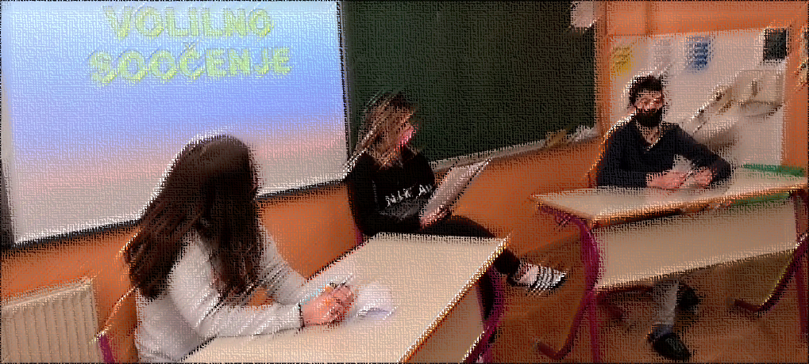

PART 2 - MAKING A REALITY THE VARIOS FORMS OF OPEN SCHOOLING - THE NATURE OF MISSION BASED LEARNING

TEACHERS

Open schooling is an opportunity for students to study things in the school curriculum in a more engaging way
A way to connect the school with reality which allows students to deal with real issues connected to their interests.

Open schooling is extremely useful for students, they develop a different vision of “how we learn”, “what we learn”, “how useful the information learned is”, they understand that another way of learning, “learning through missions” is much more creative and attractive
For us the basic principles for open schooling and Mission Based Learning are:
-changing the role of the teacher from the information provider in guiding the students on the way of documentation and research
-change the curriculum in the sense of changing the abstract way of teaching with an innovative, creative way, based on discovery
-changing the evaluation of students in the sense of topics based on research and documentation and not on memorization
-existence and use of modern means of work focused on new technology that facilitates rapid access to information for students, subject them to unique challenges and ensure their direct contact with modern and innovative education

The main motivation to work on open schooling and MBL ways is both curiosity and the idea of experiencing a foreign educational system
All that is needed is just motivation and backing from the school, teachers, community and foreign partners. Not even that; maybe just a friend's cheers are enough sometimes. All it comes down to is how well the leader feels in the school environment, and that's what most missions' preface should be
It is crucial to let the students do the work themselves and only interfere as teacher when necessary. Otherwise, the freedom will be limited and the students might not do as well. Creativity should be at the hands of the students, only the rules should be made by the teachers. Often students come up with great ideas
The learning missions were their creation, the teachers stimulated their imagination and the students found the "learning missions". For this reason, they were quite involved in solving their missions
We work in teams and we like it, because we share experiences with our classmates. We can help each other and we can develop our strong abilities as well as face challenges together
Open Schooling can give answer to the necessity to give more chances to our students, more reasons to surprise them and to awaken their curiosity as well as the need to communicate, observe and learn

STUDENTS

The students agree that Open Schooling is an opportunity to study plus it's more entertaining than regular class
Through the missions they participated in the open schooling. They learned things, developed skills through more creative, more interesting and less stressful actions
Students are interested in promoting the learning" activities implemented by them. They consider that what they have achieved is the basis of a curriculum at the school's decision, that the information gathered by them through research and documentation is extremely important for other students.
Students want more freedom in their schooling, so once Open Schooling came along, the motivation given by liberty came with it

The students chose the "learning missions", they were happy to work on their implementation. They were creative and innovative and learned a lot: how to organize an exhibition, they learned about entrepreneurial activities, they learned about the history of our city, they thought up and made from start to finish a tourist site, to model and make a school magazine. They participated in the "open schooling" process
Our students were satisfied with what they accomplished, with the chosen “learning actions”, they consider that they have successfully implemented what they set out to do and represent a good example for “open schooling”
Students are happy when school allows the world outside to enter the school or when they can bring the school (themselves) out and show what they are and what they are interested in. They feel they are taken into account
Students say they need more chances like this to put their skills into practice

Future-ready students need to exercise AGENCY, in their own education and throughout life. Agency implies a sense of responsibility to participate in the world and, in so doing, to influence people, events and circumstances for the better. Agency requires the ability to frame a guiding purpose and IDENTIFY ACTIONS TO ACHIEVE A GOAL.
OECD, “Education 2030”, 2018

The key principles of open schooling and mission-based learning that make the young students prepared for a life in the 21st century

What we know from recent research, pioneering and practical experience is that the new generations of students learn efficiently when the following conditions are met:
- the learning is relevant to the young students’ life
- the learning is carried out in narrative forms known to and appreciated by the students
- the learning includes considerable virtual activity and interaction
- the learning allows the young students to develop critical attitudes towards society
- the learning allows the students to work independently, to accomplish something real and to make their voices heard

This is what is meant when referring to 21st century students.

The key principles of such learning are embedded in the very definition of a mission.
Many types of missions are possible and very many directions might be taken, as no manual is possible or even useful. Part of the learning is precisely about the ability to find your own way.
Nevertheless, and no matter how open the missions might be and how many different ways there might be to accomplish the missions, all missions should bring into play a number of key characteristics.

Why is that?
Because these principles are the ones that ensure strong learning!
If these principles are not respected, the learning will either not occur, or be too weak to be useful and sustainable.

Let’s mention the most important principles in open schooling and in creating missions for learning, regardless of the topic addressed:

The 12 statements below constitute what we call “The 21st century young students’ Credo”

- REAL TIME and REAL-LIFE
The new young students need to work with real-life problems and challenges, not with artificial cases or text books; they strongly need relevance.
The new generation needs to work with matters that take place in and are important to their own time and life, not matters that belongs to another time or world.

The missions can go in very many directions. The “juice” of the missions is not what they wish to accomplish at the end (the results), but what kind of learning and new experience they create on the way.
However, the missions need to engage in things that take place here and now in the communities (physical, social or virtual), or in emerging initiatives bringing about new things. They must be real-time oriented and link to what is happening here and now. They must also be real-life oriented: missions built on simulations, artificial challenges or purely theoretical activities are not relevant in this context, as they do not create the needed respect, engagement and… deep learning.

- CHANGE ORIENTED
The new students need to be able to impact the reality around them; they need to feel that they can change things and not just observe things; OECD: the young students will learn through becoming change agents

- LEARNING ON THE FLY
The new students create knowledge when they need to do so and from a wide range of sources that they identify themselves; they build knowledge when it is relevant to their activity, to accomplish their “mission”.

A lot of learning takes place in the missions, but this learning is another kind of learning than in the classroom:
- it takes place when it is needed to solve problems at the different levels (situated learning)
- it takes place when the learning makes sense and is important (learning when needed and on demand)
- it takes place closely linked to real-life activities and challenges (relevance)
- it takes place when frustration arises along the mission process (motivation)
- it is practically useful to the learners (theory and practice closely linked together)

So, the missions turn educational didactics upside down:
- in traditional education you learn in theory for 20 years and then start approaching practice and real-life
- in mission-based learning you work in real-life and insert learning elements as needed

- COMMUNITY
The new students need to learn in interaction with various forms of resources, from the local physical community as well as from their global virtual social and gaming networks.

- COMPLICATED
The missions must be complicated, just like good computer games.
Not complicated in the academic sense, but complicated because many activities are needed, collaboration with many people is needed and because only a clever step-by-step strategy will allow moving from one level (activity) to the next.
Whereas many learners will step back in front of academic complications, they do not have to fear this kind of complications.

- STEP BY STEP
The key method in our missions is precisely inspired by good and immersive computer games: the mission is complicated and we cannot simply make a big jump and accomplish this mission. Not possible. What, then?
We need to proceed as the good computer games: step by step, level by level. We need to build up the capacity to accomplish the mission.
The art of missioning is precisely to take the right steps in the right order and slowly build up the needed resources, alliances and power to accomplish the mission.
This often includes very many steps, along which we must learn, explore, build alliances, create plans, demonstrate our project, create economy, negotiate and struggle our way towards making the mission impossible possible.
Each successful step represents new resources and new alliances and new opportunities, allowing us to take the next step.
To some extent the needed steps can be planned, but in many cases the stepwise progression will need to be adjusted to what really happens along the first steps.
Such processes and efforts generate strong and sustainable learning…

- OWN INTERESTS, DEDICATION and CHALLENGING
The new students are driven by their interests and passions; they ask “why should I engage in this” and are not anymore driven by the educational systems abstract reasoning (math on Tuesday from 08 to 10) or by the obedience of previous generations’ students

The mission must call for strong dedication – from the learners, but also from the professionals involved. The mission should be so interesting and attractive that dedication is constantly reinforced along the work processes.
Dedication is needed to create learning, not only to reach the goals defined.

In other words, the mission must challenge the learners involved, not please them.
They must be challenged with missions that they could not imagine being involved in. The mission itself must be able to create respect and dedication among them.
The missions must be able to overcome their well-justified resistance to “well-meaning” activities from the educational system. They must create a feeling of brand-new ways of working and being engaged in challenges that few other people will be offered. The average underdog becomes the alpha dog…
- BALANCING WISHES AND REALITY
It is a basic and absolutely necessary principle that a mission is based on the interest, skills, talents, dreams or aspirations of the learners. If not, the mission will fail big time. No engagement, no long-term dedication and no learning.
However, it is precisely a key role of the mission facilitators to prevent any naïve or totally useless mission from taking place.
The ideas of the learners must be balanced and assessed against what makes sense, what is useful, what other people might appreciate and what can result in valuable and well-completed missions.
The mission facilitators must be brave and direct and willing to counter and prevent such naïve or useless initiatives. This is in fact taking the learners seriously, and at the end it will create respect among the learners.

- INVOLVES MANY 21ST CENTURY SKILLS AND COMPETENCES
Working and struggling through such challenging missions will create very many and very important 21st century skills and competences. In the classrooms most learners will not even come near such competence development…
Along the mission steps you need to analyse reality, seize opportunities, negotiate with community players, collaborate with alliance partners, present your mission with creative media, draw up financial plans and budgets, etc., etc.
Evidently those are key competences in the 21st century, highly appreciated by many companies and often more valued now than long theoretical academic educations.
The point is: if we present such learning challenges to the learners in the abstract forum of the classroom, they will step back.
When these learning challenges emerge from the progression towards accomplishing their own mission, the motivation to learn will be 10 times bigger.
It’s that simple.

- AGENCY
The new students learn through building capacity to take action, to interfere with reality, to plan a project and to accomplish missions; they do not learn to act, but learn through acting, through accomplishing.

- ACCOMPLISHING
The new students need to learn through accomplishing things that matters to them, but also to other people; in the classroom the students do not accomplish real things in real life; everything is about remembering content.

However, and most importantly, mission-based learning – while assimilating and bringing to life the best elements from these learning strategies – adds the intentionality and agency of “accomplishing missions”.

- WHO SHOULD BE MISSION FACILITATORS?
Who are the professionals to support the learners in their missions?
In fact, teachers, academic professionals and social workers might not always be the best mission facilitators, as they carry a big burden of traditional academic mentality towards which many learners have created resistance along their often-problematic educational careers.
If such professionals are involved, they will need to struggle their way out of their academic world and bring about a lot of changed mind-sets.
Often youth workers, seniors, sport trainers, community role-models or entrepreneurs are much closer to what it takes to support the learners’ mission work.
Such people are often less pedagogical, more direct and straightforward and will be able to establish better, open and more uncomplicated relationships with the learners, built on practical collaboration in the missions.

Impact of mission-based learning

Therefore, no matter the concrete aim and result of a mission, it should create the following outcomes:
- new capacity, skills and competences among the learners to break out of mainstream passivity
- the learning must be transferable to other missions and contexts
- the learning created must be sustainable and long-term useful to the learners
- a new mentality among the learners, allowing and encouraging them to engage in similar missions in the future, if and when needed, and preferably allowing them to serve as role-models for other learners
- the mission should bring about a significant change in the learners’ attitude to learning, or as a minimum the resources to create such change
- the mission should create something new in real-life, such as in the local community or in virtual communities
- the mission should, to be successful, create something useful or attractive for other people; something that other people would like to use, participate in, buy or in other ways appreciate
- the mission should aim to create sustainable outcomes: what is accomplished by the mission should be continued, transferred or even expanded

What is not a mission

Let us close this small description of the nature of Mission Based Learning with what a mission is and should be by indicating what cannot be considered missions (because such activities do not create deep learning):
- any punctual or short-term activity is not a mission
- activities prepared over some time but still simple activities without further perspectives are not missions
- engagement in already existing and running initiatives is not a mission
- involvement in practical activities in the institution or in the community is not a mission
- activities that do not create something new and useful for the learners and other people are not missions
- simple activities easy to accomplish are not missions
In short: activities that do not create deep learning are not missions.

A mission is therefore defined by the learning it creates among the learners and the dynamic perspectives it offers.

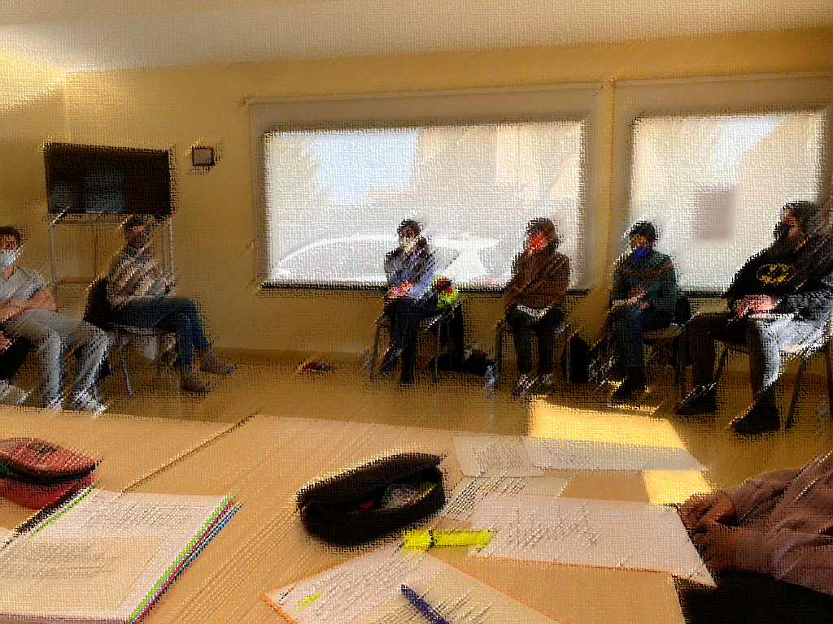

PART 3 – DRIVING THE CHANGE

TEACHERS
This project was an opportunity for our school to understand how to make the transition to "open schooling", to change its mindset, to acquire creative teaching skills, to be able to present to other schools an example of good practice, an example of how change can occur
The scheduling is down to how much time the head staff is willing to sacrifice to fit in the extra-curricular stuff, like Open Schooling. Besides, the students are clearly showing interest, therefore OS should take up a significant part of the curriculum. It perhaps depends on the individual school; in our case, some lessons should just be swapped out with OS activities
Teachers need to be aware that the educational system in which they are evolving is outdated, teaching and assessment methods obsolete. There must be a desire to change the mentality of teachers, the need to learn new things and to implement "open schooling". In our country the educational system must be reformed, new guidelines must be established to change the outdated approach, to support teachers to "change", to become vectors of change, to implement creative and innovative learning methods.
Teachers need the support of the Ministry of Education to participate in training courses to help them find more creative ways to work
The challenges in our school are many:
-we have an outdated educational system with extremely difficult and busy learning programs, much more loaded with notions than in other European countries (our students’ study in high school what is taught in other schools at university level);
-students have a very large number of 6-7 hours every day and every teacher have to teach them extremely difficult content which they fail to cope with and, as a result, often give up;
-teachers have a lot of other tasks besides the classes, various paper work to do, statistics, etc., they are overworked and so often the classes become a chore;
-lack of motivation of teachers due to low salaries offered by the state educational system;
-an education based on abstract notions and not on learning based on practice, based on real life examples; the buildings of the school units are not modernized, the spaces do not comply with the current norms, spaces that do not have working means-laboratories, sports halls, computer rooms, all are insufficiently equipped and non-compliant.
In conclusion, our education is chronically underfunded, aging, and if we still have great students, it is the exclusive merit of passionate and kind teachers who work with them and try to make up for the shortcomings of the system
Teacher needs to find a way to implement small missions in the “big” Mission so that students keep motivated and feel they are reaching small goals. Students need to see results to be motivated and have small rewards (knowledge, activities) they feel as interesting or fun
It is important to give teachers more time to prepare the activities and to find ways to connect the world out of the school with the school. This kind of projects need the complicity of different agents and resources and it is not always possible to establish them in between classes, as we usually do. The lack of time is an important issue.
At the same time, when you open the spectrum of possibilities for the students to choose, you need time to foresee and predict the paths you will be able to open to them, so that you can offer interesting sources which will allow them to widen their knowledge and skills.
We need agreement among teachers, team work, good atmosphere and time to coordinate ourselves. We also need proper spaces, less students in class and good links out of the school (stakeholders) to cooperate/work with
Nowadays it is a challenge to find:
Engaged teachers - in order to have a good team of teachers.
Engaged stakeholders - which are willing to collaborate and adapt their organisations to the school schedules and needs
We need more time to share with the all the school team, so that all teachers and directive team take advantage of the work we do. Sometimes we all work in parallel and we don’t have time to share. Sharing is the key to make our work more profitable and develop it into further experimentation

STUDENTS

The students say that it's all up to the staff as well. All they can do besides that is just give more time for OS AFTER the usual curricula.

All them agree they would like to devote more time to this kind of projects. Sometimes the development of the project itself is overlapped by other tasks we must accomplish to coordinate our teams with other partners. If these tasks have not been planned by the Erasmus+ project coordinator in advancer from the beginning of the project, it makes teachers and students a bit anxious sometimes.

Encourage “open schooling” where schools become an AGENT OF COMMUNITY WELL-BEING.
EU Commission, Science Education for Responsible Citizenship, 2015

The reality

A unanimous European policy and research community strongly recommends using co-driving and co-creation as basic principles when fostering innovation interest, skills and capacity, also in early schooling.

In practice this means that the YOUNG PEOPLE will need to create innovation interest, skills and capacity through real-life and real-time and practical projects, not through classroom instruction and theoretical exercises.
This is paramount to the creation of authentic innovation interest, skills and capacity.

However, the same is true for the TEACHERS: they will also need to create didactic competence in the field of fostering innovation mentality, and they will have to do this through practical projects working side-by-side with the students.

Practical experimentation in many schools from across Europe clearly evidence that no teachers are prepared to work in innovation missions or in open schooling!

The teachers engaging in such experimentation are front-runners and pioneers, dedicated to bring about change in school education.
They struggle to make this happen, and sometimes they need to step back: the obstacles are difficult to overcome and the workload too demanding.

In general, teachers in secondary school are under pressure - tests, competition, funding based on student grades, evaluation of teacher performance, etc.
Most teachers therefore do not wish to engage in innovation, or they might wish to, but do not have the support or the needed resources.

This means that European and most local experimentation are driven by very few pioneer and brave teachers.

When they manage to engage in for example a European project based on open schooling like Mission Based Learning, they mostly have to manage everything themselves, and often without additional resources from the school.
These teachers are the real heroes of experimentation.
They want to change; they want to do good for the students.
But after a few years on their own, many of them burn out and give up.
The lack of serious support from the school and from the educational system usually allows these teachers a limited number of years in the project world.

But the students, at least, are openly interested in innovation, right?
Wrong.
The classroom mentality is also and sometimes very much shared by the students! They are used to being told what to do, how to do it and when to do it.
They are excited about the new project initiatives, but they are still positioned in the old educational mentality. Even if they are digital natives, as they do not link education with their mobiles’ phones at all.

Most students at this age have long ago given up asking about the relevance of the school work and simply try to pass the school time and go home to the “real activities”.

An interesting experience is that if the students get too much of the innovation, they start to ask the teacher what this is all about.

So, the classroom mentality is in the blood of all the players.

Traditionally, SCHOOLS are increasingly top-down controlled by educational authorities and are increasingly concerned with scare financing and a lack of resources.

School boards and managers are to a lesser extent able to engage in innovation and experimentation.
Mostly they tolerate projects with reasonable funding, but they also mostly prefer to see those projects as “special events” with little impact on the school organisation and practice.
Most European schools do not have the needed room to move – their hands are tied, and that does not make life easier for pioneers’ and braves teachers.

Schools and students as drivers of change

This section is addressing teachers and schools that might like to take the students’ innovation activities further.
They might wish to take the engagement from a student team level to a school level – a “school in the community” level, so to speak: the school doing what the student teams are doing.

Now, what is that about?
Traditionally, schools are responsible for education in classes, tests and exams, not engaging in any form of community activity, in community politics or community innovation.

In the limited version open schooling is about students’ and student teams’ learning through interaction with the community and real-life challenges in the community. In the extended version open schooling is about the engagement of the school as organisation in community challenges.

In a 21st century context innovation is no longer expected to only be driven by public authorities or major private enterprises within a top-down approach.
On the contrary, innovation is expected to be driven by citizens, all sorts of community resources – and by any stakeholder in the community able to and willing to drive change.

Such a stakeholder able and willing to drive change might precisely be… a SCHOOL!
Of course, this is not obvious if we think about a traditional school. The traditional school will mind its own business, so to speak.

But what about a school that:
→ organises open schooling activities for teams of students to create innovation interest and mentality
→ works to create entrepreneurial mentality among its students
→ increasingly integrates real-life challenges in the students’ learning
→ would like to be a pioneer school offering its students 21st century skills and competences

What about such a school?

This school might be willing to take the innovation engagement to a higher level, from a few student teams to the school at large, and to integrate open schooling didactics more and more in the schools’ learning activities and in the school’s “identity”.

Interestingly and importantly this school has the full support of the European Commission
In fact, the European Commission encourages schools not only to be more active in the community, and not only to facilitate students’ learning through community interaction – but to play the role of drivers of change and innovation in the community…

The reasoning of the European Commission is at the same time extremely advanced and really simple:
- now, when we organise open schooling activities for students, learning through community interaction, and support the student teams’ engagement in innovation, why not see this form of activity as a resource for creating bottom-up and citizen-driven innovation and change in the community?
Why not allow the community to benefit more systematically from these new learning processes, offering students powerful learning and creating change in the community at the same time?

One thing is sure: the more “real” and “serious” the students’ engagement, the better the students’ learning and the more benefit for the community!

In short, such a school works to integrate its learning activities in the life and needs and future of the community.

In this way the school becomes an important stakeholder in the community, becomes a driver of change and initiative-taking - and becomes a meeting place for innovate resources in the community.
And, not to forget, becomes a pioneer of 21st century learning, from which the students will benefit tremendously.

This will give new life to the school and will offer the school important social dynamics to invest in the students’ future-oriented skills and competences.

Easier said than done, of course…

Such engagement of the school as driver of change needs strategic planning, dedication and pioneer spirit – from the management as well as from groups of teachers.

How this could happen
Let us try to give some advice on HOW this could happen.
Each school will find its own way, but there are certain general approaches that we would like to share:

- STRATEGIC APPROACH
Schools wishing to engage in such roles as drivers of change and innovation are strongly recommended to apply a strategic approach: careful discussions and preparations are needed, and in particular it is important to build on strong consensus among management and teachers, as well as create serious dialogues with potential community alliances.

- BUTTOM UP
It is also of the utmost importance not to create top-down initiatives through organisational agreements between leaders and managers in the community resources: ecosystems.
The extended roles in the community of the school should build on the students’ open science schooling engagement and take this engagement to a higher level.
This bottom-up approach will ensure that the school’s engagement is continuously focused on the students’ learning and co-driving.

- STUDENTS’ CO-DRIVING
The ultimate aim of the school’s new ecosystems roles is to offer students’ relevant 21st century learning opportunities. To maintain this aim students should always be at the centre of the school’s engagement, as co-drivers of the innovation missions.
The school should not attempt to replace the students’ engagement, on the contrary: the new roles of the school should increase the quality of the students’ learning and allow more and more students to engage in and benefit from open schooling.

- CREATING ALLIANCES
One of the prominent new roles of the school, in support of the students’ innovation science missions and innovation learning, should precisely be to continuously build new permanent alliances with institutions, resources and citizens in the community, this means a continuous ecosystem building process. In this way the school will allow the students to benefit from a still growing eco-system of collaboration in the community and will allow the community to benefit from a systematic and sustained engagement of the students and the school.

- SHARING THE STORIES
The school should take advantage of its new roles and of the students’ innovation missions: it should systematically share the stories with all relevant resources in the community and describe the benefit of the engagement for students and for the community and its citizens. Visibility is key…
Evidently, the students must be deeply engaged in this sharing, including through the social networks.

- EXPLOIT FUNDING
In case the school is willing to take on such new ecosystems, the school will inevitably become a pioneer school. This means that the school can apply for a variety of funding – from local and national funds to the European programmes.
This is a great way to create more economy for the activities and to share the new experience in wider circles

- OPEN SCHOOLING MAINSTREAMED
Most schools will start its new pioneer journey through engaging a few student teams in such innovation science missions.
It is important for the school to build further engagement on this practical experience.
However, as soon as the school wishes to extend the science missions to more students and to widen considerably the number of students engaged in such open science schooling learning, it will be necessary for the school to take the approach to a higher level: precisely to a “school as organisation” level.
It is at this point the school will benefit from engaging as driver of change in the community, as this would be the best framework for engaging more and more students in innovation learning.
Mainstreaming open science schooling for innovation learning might precisely happen through the systematic engagement in community innovation of the school as organisation.

You will find examples of missions-based learning through studying the material in the MBL website

SUMMARIZING
Open schooling and the interest in innovation will require no less than a revolution of the entire education system.
This will probably and inevitably lead to apathy and giving up.

Schools and teachers cannot wait for the education system to change; first of all because it will not change; second, because if it should change it will take decades.

Schools and teachers, and their local/regional educational authorities, are therefore challenged with the mission to find out to what extent it is possible to create as good and authentic open schooling engagements for the students as possible.

Policy-making should ensure increasing self-governance in schools, allowing the experimentation needed in the globalised 21st century.
Open room to move should be integrated in all educational planning and curricula.

Small first steps might lead to more engagement.

Remember that the Commission knows all this. This is why the Commission encourage “rule-breakers”; in the sense of schools and teachers experimenting with new didactics even if the education system is not moving.

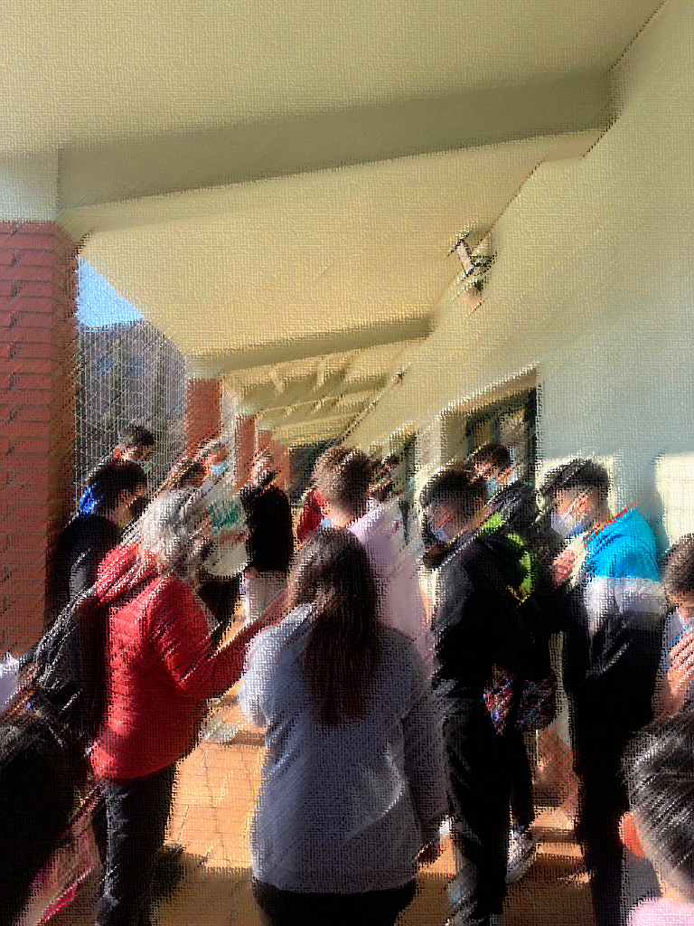

PART 4 - THE COMMUNITY IN MISSION BASED LEARNING SCENARIOS

TEACHERS

Collaboration with community resources can be done through partners in the community which can outsource the resources needed for the missions

The collaboration with the local community started when the project was disseminated in the community. Thus, we had the support and collaboration of various NGOs and associations, private companies and other schools. We have also collaborated with the County Library, with several museums in our research and documentation missions. The process has been very interesting
Students investigated about different issues related to different areas of their interest and the local community, and they suggested proposals to take action.
They studied different options and the pros and cons.
They took action.
They saw the effect of their action.
They told their story.
Then, when they were telling their stories, they realized they were working in missions
Community resources can be established with good knowledge of local institutions, organisations and enterprises. It is very important to work on the development of a network which allows the school to establish links with organisations out of the school which will favour the development of projects. It is important to know well the reality of the local community in order to generate initiatives which will have a real impact in the students

STUDENTS

Students are very interested in contacting professionals and headmasters of companies and institutions in and around town.
The students found various collaborations, involved parents but also people from the community to support them in their learning missions. They participated in other activities than the ones they were used to and this relationship was extremely positive for their development.
In our case, students were very happy to work with real stakeholders. They got to know adults in their community who were happy to work together with them and to offer them their support, their installations or their knowledge, depending on the case

Education institutions should be encouraged to become more entrepreneurial in their wider approach, to ensure that they develop and live a culture of entrepreneurship and innovation through their missions, leadership, stakeholder engagement, curricula and learning outcomes.
European Commission, “Entrepreneurship 2020 Action plan”

In the contexts of mission-based learning, we use expressions like “eco-systems of community collaboration” and “infrastructures of community collaboration”. The terms are more or less interchangeable.
When we talk about school becoming an agent of change in the community, one of the most important and continuing tasks is precisely to create permanent collaboration between key stakeholders in the community.

There are two reasons for this:
- to be an agent of change the school must develop very close relations and collaboration with key stakeholders in the community, as these stakeholders are expected to be involved in most change actions and missions. Such stakeholders might be the municipality or a regional public authority, a chamber of commerce or business centre, a research centre or innovation centre – and some sort of citizens’ association if it exists
- the school is continuously responsible for creating such collaborative structures for the students to tap into when they detect, define and work in their change missions; it is not realistic that student teams would have to establish such basic collaboration from scratch when working in their missions; the basic collaborative resources should be available to them

The Mission Based Learning project was based directly on the European Commissions’ Entrepreneurship 2020 Action plan in which the Commission encourages education institutions to become more entrepreneurial in their wider approach ensuring that they develop and live a culture of entrepreneurship and innovation through their missions, leadership, stakeholder engagement, curricula and learning outcomes.

The schools as drivers of change need to create what we call permanent teams of community collaborators for the student teams to take advantage of when working on their missions, the mission-based community collaborators are ad hoc collaborators specifically linked to a specific mission.
The students’ team will create this ad hoc collaboration when detecting, designing and implementing their community missions.

In the project “community” was understood in its widest sense: local physical community, the region and virtual communities.
The globalised world and the 21st century students do not separate these worlds in the way the present educational systems do.
They work with the physical and virtual communities as one world, and obviously, community engagement might very well include considerable virtual social networking.
And this is why the project invited the students to work in different forms of communities along their missions. A number of people and institutions from various forms of physical and virtual communities were involved through the students’ missions.

One thing is for sure: there are no “right or wrong” communities.

The ROLES OF THE COMMUNITY are many and important in open schooling scenarios and experimentation.
In fact, the vision is that most of the learning is expected to take place outside the classrooms and schools, and strongly linked to real-life activities, supplemented by “learning on demand and when needed”.

However, the reality is that innovators, entrepreneurs and professionals are not at all used to and geared to collaborate with schools and students along considerable time periods and not at all used to integrate student teams in their research and innovation circles.
They are used to punctual engagements only: meetings at the school, students’ visits, workshops, events and similar.

And the reality is that communities and their professionals can only develop such collaborative competences through continued practice.

These players are deeply engaged in their missions, but they do not know how to handle open schooling.

Open schooling includes long-term engagement of students, students following the life circle of innovation and students going as deep as possible into the mysteries of the innovation, including its many cross-subject implications and directions.

Community collaborators need a strong outlook to see the meaning of this interaction.

Once the communities are mobilised to work with open schooling, the community will be able to deliver important resources to the schools and to the teachers.
Then, early learning will become a collective mission, not simply a school responsibility.

The point is, however, that the mobilisation of the communities requires many rounds of (accumulative) experimentation, and it doesn’t happen if schools and teachers are not given the needed space to create such experimentation.

Therefore, the mobilisation of community stakeholders for innovative learning is depending of the resources of schools and teacher to create and drive the experimentations.

All this is closely related to how the innovation in education is depending on schools, teachers and students’ motivation.

This simply means that all the players in open schooling and creating innovation interest among students must learn: the educational players as well as the innovation players – and the educational authorities that should support those activities actively, but rarely do so…
The point is, however, that the innovation players might benefit strongly from this engagement when they learn how to use the long-term contact with the future generations of citizens!

To quote once again the simple OECD words:
“Users are being involved in earlier phases of the innovation process - already when companies are identifying opportunity areas. The innovation process is becoming user-driven.”
OECD, New Nature of Innovation

Obviously, this will take much experimentation and much learning among the innovation players.
In particular it will take sustained activity, creation of eco-systems of collaboration and evaluation of the innovation players’ benefits.

If pioneering and experimentation are not supported locally and nationally, the education systems will lose its dynamics, its creativity and its ability to change and address new challenges and therefore the schools will not have the tools to move and build such eco-systems of open schooling in the community.

All this process needs time, years, and the problem is: who will fund, invest in and drive such sustained and long-term experimentation?

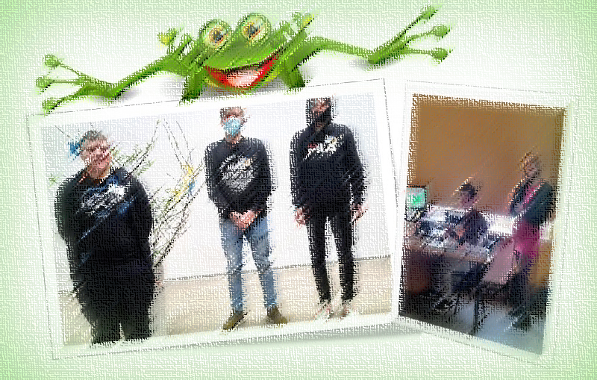

PART 5 - POLICY SUPPORT AT EUROPEAN LEVEL

TEACHERS
The way we see it the role of local authorities could be:
-facilitating the organization of clubs for teenagers: robotics, painting, dance, music, etc.;
-removing the bureaucracy in obtaining approvals for various actions undertaken by young people;
-organizing competitions on various topics to stimulate the creativity of young people and to constitute "open schooling"
-awarding students who excel in various innovative learning activities
-stimulating young people to participate in various activities based on the needs of the community-clean-up campaigns, promotion campaigns, various activities necessary for the community, aid campaigns for people with disabilities, etc
Public authorities should allow students to freely involve things like Open Schooling in their curricula and be able to choose what things they want to study on their own as well as in a group. They should also be financed to draw links between their country and foreign countries in Erasmus as well, because in this case OS co-operation is necessary for a common cause.
Public authorities should work to give schools and teachers more time and resources to work on the development of these kind of projects. The everyday work teachers have to develop the curriculum with students is usually difficult to combine with the development of the projects

STUDENTS
The students are dissatisfied because in the case of our city the local authorities do absolutely nothing for the development of the young people, for facilitating their access to "open schooling".
Students want more freedom to work and travel to schools of overseas partners. They wish they got more aptly financed, just like the staff does.

Schools should develop sustainable and systematic partnerships with businesses, social enterprises and NGOs rather than ad hoc links.
Create 'open door' policies in schools to make them accessible to their local communities; and enabling them to draw on the skills and talents of local people.
Budapest Agenda, “Enabling Teachers for Entrepreneurship Education”

Due to the lack of real interest in educational innovation from national policy-making, this innovation depends increasingly on policy, research and practical experimentation at European level and backed-up by European funding.

Whereas national educational policy-making seems increasingly closed around short-term national budgets, European policy, research and practical experimentation can be driven by long-term and future-oriented innovation strategies anticipating competence needs in the 21st century and beyond.

The precondition is, however, that European policy, educational research and educational practice join forces and delivers useful models and guidance to schools and teachers, backed-up by serious and proper pioneer funding.

What’s going on?

- European policy
Creates strong and powerful platforms for educational innovation, but the European level policy-making is not sufficiently followed-up in and channelled into the European funding programmes

- European educational research
Delivers rich evidence as to the benefits of educational innovation; however, most of the research is not sufficiently linked to practical experimentation and therefore does not reach many schools and teachers: the well-known innovation implementation gap.

- European educational practice
Is increasingly depending on European funding, as national funding becomes scares and hard to reach; European funding for schools traditionally means Erasmus+, as this is the only programme for practical educational experimentation.

In short, the European Commission indeed delivers a strong platform for educational innovation, but this is not followed up by solid collaboration between educational research and practice.
It is therefore a major challenge to educational innovation in Europe to bring together educational research and educational practice.
In fact, any positive change in education in Europe is depending on this.

This was clear in the Mission Based Learning project – a project precisely making an effort to contribute to how to create open schooling innovation interest and capacity among students and schools– an effort at the heart of European policy.
However, the project was not really able to tap into a research and practice community systematically addressing the challenges linked to such experimentation.

As so many other Erasmus+ projects Mission Based Learning needed a strong and systematic policy and research contexts at European level.
This means a tremendous loss of resources for educational innovation in Europe.
The management of Erasmus+ by national agencies, resulting in a long line of national peculiarities, and the devaluation of the Erasmus+ programme in general (250 euro per month to implement a complicated and highly needed project!) is not making it easier or more attractive to schools and teachers to engage in educational innovation.

For European educational innovation to become efficient and useful Horizon and Erasmus+ (and what will follow from 2022) will need to join forces in a very different way than has been the case so far.

Joining forces

What are, then, the 10 key challenges for joining forces for educational innovation at European level?

- Educational research in Horizon and successors should increasingly be focused on and directed towards the key challenges in open schooling/mission-based learning as the most promising didactic platform for creating entrepreneurial, innovation and research interest and capacity in early schooling

- The educational research projects should perhaps put more effort into requesting mixed partnerships of research, schools and community players, as open schooling can only be researched through interaction between schools and the community

- Erasmus+ and successors should be managed by the EACEA under the European Commission, and the programme should be considerably upgraded to support the challenges linked to open schooling experimentation

- Erasmus+ should be modernised to include strong cross-sector initiatives in support of authentic open schooling experimentation and knowledge creation, not simply reflect the traditional structures of the education systems

- Erasmus+ experimentations should include clear research contexts to ensure sufficient knowledge feed and continued knowledge building

- Students’ co-creation of innovation should be made a strong focus and methodologic requirement in all these experimentations, including in Horizon and Erasmus+ projects addressing educational innovation, as students’ co-creation is key to success in the 21st century

- Formal infrastructures should be in place to support the collaboration between research and practical experimentation; the interaction with these formal infrastructures should be made a focus in research as well as practical projects

- The educational practice players – educational authorities, schools, teachers, students and open schooling community players - should be involved in the full educational research circles, from research design to practical implementation

- Educational research at European level should engage in solid re-thinking of its fundamental research paradigms, as much education research seems not to be able to sufficiently dismantle traditional research paradigms, think forms and work forms; much educational research is embedded in traditional academia

Recomandări pentru cercetare și experimentare practică

Ideile noi inovatoare și soluțiile creative apar adesea la interfața dintre discipline și implică diferiți actori societali. Inovația este legată, direct sau indirect, de experiența, nevoile și problemele umane. Acest lucru se poate întâmpla prin implicarea in artă – cântând sau ascultând muzică, dansând, experimentând sau creând artă, vizionarea și crearea de videoclipuri sau filme sau implicarea în proiectare și realizare.
Comisia, Educația științifică pentru o cetățenie responsabilă.
Recomandările de învățare bazate pe ”misiuni” pentru cercetarea și experimentele practice la nivel european sunt:
- sunt necesare inițiative de cercetare axate direct pe școlarizarea deschisă și abordările de co-creare ale studenților care vizează stimularea interesului de cercetare, antreprenorial și inovare în rândul elevilor și școlilor, deoarece școlarizarea deschisă este cheia majorității inovațiilor educaționale din secolul XXI.
- inițiativele de cercetare ar trebui să solicite implicarea directă și co-crearea unor actori cheie ai comunității de școlarizare deschisă: autorități educaționale, școli, profesori, studenți și resurse comunitare în domeniul cercetării și inovării.
- cercetarea ar trebui să fie legată strâns și sistematic de experimentarea practică, iar experimentarea practică ar trebui să contribuie la acumularea de cunoștințe solide în domeniul școlii deschise.
- co-crearea studenților ar trebui să devină o prioritate în toate cercetările și inovațiile educaționale și în toate experimentele practice.
- cercetarea și experimentarea practică ar trebui să contribuie puternic la înțelegerea diferențelor radicale dintre generațiile prezente și viitoare și generațiile mai vechi, iar înțelegerea ar trebui să includă descrieri holistice ale noilor nativi digitali.
- cercetarea și experimentarea practică este iminentă în formarea profesorilor pentru a crea linii directoare pentru modul în care noile generații de profesori pot gestiona și dezvolta o școlarizare deschisă utilă și să învețe alături de tinerii secolului XXI.
- ar trebui să existe infrastructuri formale la nivel european pentru a permite o interacțiune puternică între inițiativele de cercetare educațională și experimentarea practică, inclusiv făcând posibilă colaborarea oficială între cercetare și proiectele practice.
- Comisia ar trebui să monitorizeze mai sistematic contribuția autorităților educaționale naționale la agendele europene de inovare educațională, inclusiv să critice deschis elaborarea politicilor naționale care lucrează împotriva inovării educaționale europene.

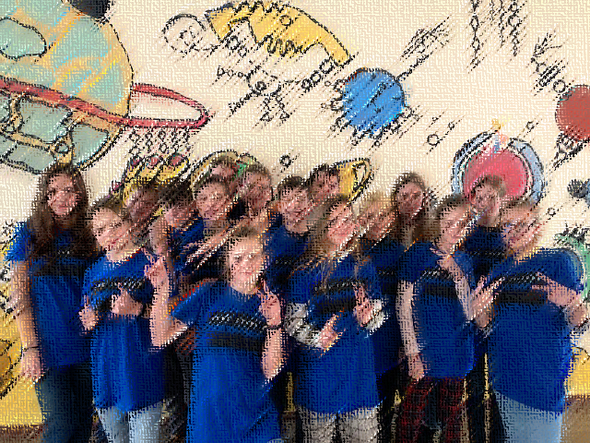

THE PROJECT SUPPORT

Perhaps you are a school benefitting from the valuable project material. However, your school and your teachers would still like to receive some kind of extra support and help – from resources with practical experience in mission-based learning to create innovation interest and capacity.

Now the project is terminated but the inspirational material remains available on the project website.

This does not mean that schools cannot establish contact with the project and with the different partners.
Of course, such collaboration is not financed, but there are ways to collaborate informally and still benefitting both parties.

Let us briefly describe what kind of support and help might be obtained from the project leaders and partners:

- guidance through simple mailing
- contact to interested schools
- a workshop visit to the Mission Based Learning resource from the school’s teacher team (self-financed, of course)
- consultancy along the school’s experimentation from project resources (to be financed)
- support and help to join European projects

There are obviously more opportunities and they will need to be discussed and negotiated in each case and when a contact is established.

Schools are free to contact the project resources and discuss what kind of support and help might be possible

CONTACTS
Coordinator: University of Gloucestershire
Contact names: Cathy Burch and Paul Vare
Contact mail: cburch@glos.ac.uk and pvare@glos.ac.uk

Knowledge partner: University of Eastern Finland
Contact name: Calkin Montero
Contact mail: calkin.montero@uef.fi

Knowledge partner: Jagiellonian University
Contact name: Marcin Kleban
Contact mail: marcin.kleban@uj.edu.pl

Quality Assurance partner: Working with Europe
Contact name: Mireia Masgrau
Contact mail: mireiamasgrau@gmail.com

SCHOOLS
Partner name: Colegiul National Fratii Buzesti
Contact name: Camelia Buzatu
Contact mail: camelia_buzatu2000@yahoo.com

Partner name: Bauskas Pilsetas Pamatskola
Contact name: Solveiga Gutkova
Contact mail: solveigagudkova@gmail.com

Partner name: Pasvalys Lėvens basic school/Lithuania
Contact name: Lidmila Gertiene
Contact mail: liudagertiene@gmail.com

Partner name: Elazig doga anadolu lisesi/Turkey
Contact name: Rahmi Dikici
Contact mail: rahmidikici@gmail.com

Partner name: Institut de Vilafant
Contact names: Cristina Mallol and Elena de la Vara
Contact mail: cmallol3@xtec.cat and mvara5@xtec.cat

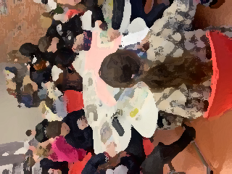

The MBL has ended, but we can still help…

