Ghid de politică

CE POT FACE pentru POLITICa LOCALă TINERII STUDENTI DIN SECOLUL 21?

Mission Based Learning – developing a realistic schooling model equipping young students with the 21st century skills
Erasmus+ KA 2 2019-1-UK01-KA201-061399
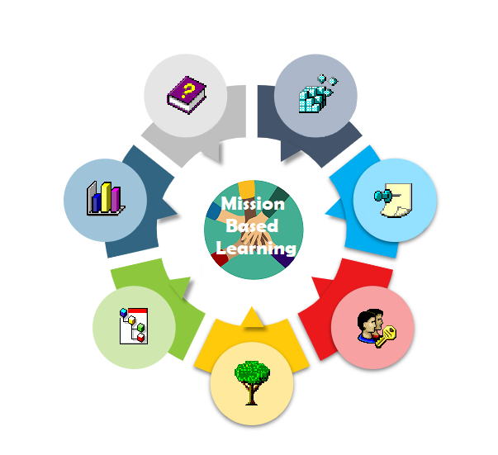
Autori:

Cuprins:

Introducere…………………………………………………………………………………..3

Surselemanuscrisului……………………………………………………………………...6

Școală deschisă: ce reprezintă?................................................................................6

De ce este importantă școala deschisă?...................................................................8

De ce elevii secolului 21 au nevoie de modele de școlarizare precum învățarea bazată pe misiune?...................................................................................................10

Cum pot fi implementate aceste modele de școlarizare deschisă în școlile gimnaziale locale fără a fi nevoie să schimbați întregul sistem?..........................13

Cum pot autoritățile educaționale să ajute școlile, profesorii și elevii să creeze colaborarea comunității locale?..............................................................................16

Care este beneficiul mai general pentru comunitatea educațională locală dat de implementarea modelelor de școlarizare deschisă și a inițiativelor comunitare?..............................................................................................................18

Care este beneficiul mai general pentru comunitate și cetățeni dat de implementarea modelelor de școlarizare deschisă și a inițiativelor de învățare bazate pe misiuni? Cum pot beneficia toți jucătorii din comunitate de pe urma școlilor și studenților ca agenți de schimbare?.....................................................19

Cum pot autoritățile educaționale locale să se mobilizeze și să conducă o astfel de inovație educațională și cum pot studenții să co-creeze inovația?................ 21

Scrisori de la elevi………………………………………………………………………... 24

Referințe…………………………………………………………………………………….25

Anexa………………………………………………………………………………………..26

Introducere
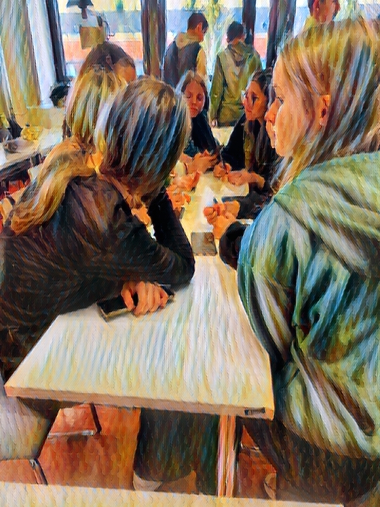
Acest document despre politici conturează concluziile și recomandările pentru factorii de decizie (educaționali) care decurg din experiența de trei ani de implementare a unui model specific de școlarizare deschisă, pe care l-am numit învățarea bazată pe misiune. A fost scrisă cu scopul de a informa factorii de decizie relevanți, la nivelul autorităților locale și educaționale, despre beneficiile care decurg din aceste practici educaționale și provocările introducerii lor în practica școlară.

[…] trebuie să avem o altă abordare în educație, să schimbăm lucrurile în sensul aplicării unor metode noi, interactive, cu o implicare diferită a elevilor – o învățare prin misiuni.
Învățarea bazată pe misiune este un model de școlarizare care deleagă responsabilitatea și luarea deciziilor tinerilor adolescenți care sunt împuterniciți să modeleze, să conceapă și să implementeze proiecte educaționale proprii. Denumirea misiune, care se referă la proiecte conduse de studenți, a fost importată din domeniul jocurilor pe computer în care echipe de jucători sunt implicate în gameplay-uri care duc la finalizarea misiunilor. Deoarece există o mulțime de dovezi că tinerii de astăzi beneficiază de pe urma jocurilor digitale în ceea ce privește dezvoltarea unor abilități precum comunicarea, luarea deciziilor, alfabetizarea digitală sau competențele lingvistice, proiectarea unei metodologii educaționale care se bazează pe principiile tipului de învățare autonomă care are loc-în contexte digitale pare adecvat.
Învățarea bazată pe misiune, ca model de școlarizare deschisă, se bazează în mare măsură pe colaborarea cu partenerii din cadrul comunității locale, organizațiile și instituțiile educationale, cele disponibile direct la nivel local, precum și cele disponibile online. O astfel de colaborare cu partenerii comunității locale aduce beneficii tuturor celor implicați. Aceasta înseamnă că sprijinul care poate veni din partea autorităților (educaționale) locale nu are rol doar de facilitator pentru școlile care implementează metodologia de școlarizare deschisă, ci și pentru societate în general.

Aceste beneficii includ un mod de învățare îmbunătățit și eficient pentru studenți, o motivație sporită a elevilor și profesorilor, internaționalizarea învățării, abilități îmbunătățite de comunicare, dezvoltarea abilităților de luare a deciziilor, abilități de evaluare și alfabetizare digitală. Școlarizarea deschisă pregătește elevii să devină cetățeni responsabili, conștienți de nevoile comunității locale, care au o atitudine grijulie față de oamenii și locurile în care trăiesc.
În timp ce ideea de școlarizare deschisă a fost susținută de Uniunea Europeană în mai multe documente de politică, articole și prin proiecte finanțate de UE, mai sunt multe de făcut pentru a promova modele de școlarizare deschisă pe scară largă în școlile europene. Acest raport indică în mod clar numeroasele beneficii ale școlii deschise și, în același timp, barierele existente în calea implementării acesteia. Acestea din urmă se referă la limitările mediului educațional cu care trebuie să se confrunte școlile, profesorii și elevii. Prin urmare, creșterea gradului de conștientizare a autorităților cu privire la oportunitățile oferite de școlarizarea deschisă, precum și la obstacolele din calea implementării acesteia poate fi o strategie de schimbare a jocului - popularizarea acestui model educațional.
Factorii politici relevanți ar trebui să fie, de asemenea, implicați, pentru a încuraja acceptarea politicilor și integrarea bunelor practici și perspective în politici și, prin urmare, sustenabilitatea și impactul dincolo de durata de viață a finanțării.
Uniunea Europeană, Școlarizare deschisă și colaborare în domeniul educației științifice (2022)
Pare clar că, pentru a face din școlarizarea deschisă o realitate, este important să obținem sprijinul autorităților (educaționale) locale și naționale. Doar atunci metodologia de școlarizare deschisă poate primi sprijinul necesar pentru a deveni o strategie educațională durabilă și utilizată pe scară largă.
Faza de implementare a proiectului Mission Based Learning a durat între 1 noiembrie 2019 și 31 iulie 2022, in ciuda dificultăților cauzate de izbucnirea epidemiei de Covid-19.

Pare clar că, pentru a face din școala deschisă o realitate, este important să obținem sprijinul autorităților (educaționale) locale și naționale. Doar atunci metodologia de școlarizare deschisă poate primi sprijinul necesar pentru a deveni o strategie educațională durabilă și utilizată pe scară largă.
Faza de implementare a proiectului Mission Based Learning a durat între 1 noiembrie 2019 și 31 iulie 2022. În ciuda dificultăților cauzate de izbucnirea pandemiei de Covid-19, acesta a atins cu succes obiectivele stabilite la început. Proiectul a implicat cinci parteneri și două școli primare și secundare, voluntari din șase țări, inclusiv: Letonia, Lituania, Polonia, România, Spania, Turcia, trei parteneri de cunoaștere: Universitatea Gloucestershire, Marea Britanie (liderul proiectului), Universitatea de Est. Finlanda, Universitatea Jagiellonian, Polonia și organizația parteneră pentru asigurarea calității Working with Europe, Spania. În cei trei ani, peste 70 de studenți cu vârsta cuprinsă între 13 și 17 ani au fost implicați direct în activitățile proiectului. Lista completă a instituțiilor care lucrează la proiect include:
- Bauskas Pilsetas Pamatskola, Bauska, Latvia,
- Colegiul National Fratii Buzesti, Craiova, Romania,
- Elazig Doga Anadolu Lisesi, Elaizig, Turkey,
- Institut de Vilafant, Vilafant, Spain,
- Pasvalio Levens Pagrindine Mokykla, Pasvalys, Lithuania,
- Publiczna SP im. św. Wincentego Pallottiego w Krakowie, Poland,
- Społeczna SP im. Lady Sue Ryder, Niepołomice, Poland,
- Jagiellonian University, Poland,
- University of Gloucestershire, UK,
- University of Eastern Finland, Finland,
- Working with Europe, Spain.

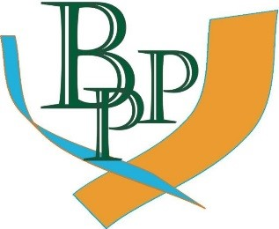
 | 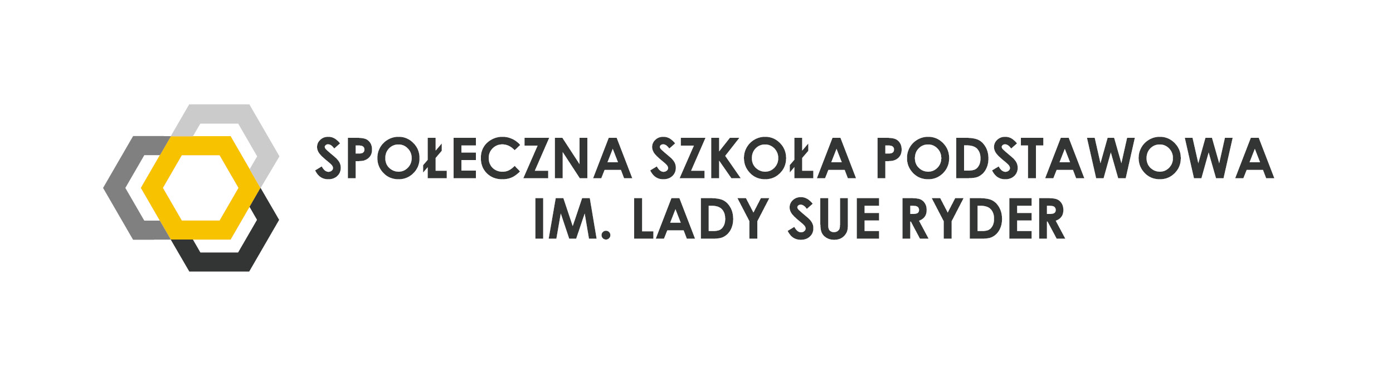 |  | 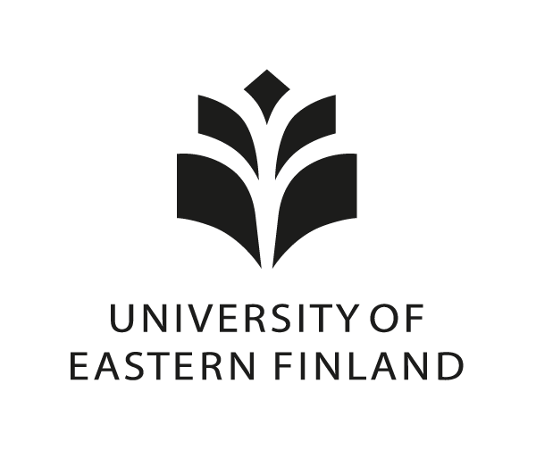
Luând în considerare numeroasele beneficii pentru școli, elevi, profesori și comunitățile locale și bazându-se pe experiențele dobândite pe durata proiectului, acest document de politici indică acele acțiuni pe care factorii de decizie locali le pot întreprinde pentru a sprijini o învățare semnificativă și eficientă pentru cei 21 tineri studenți. Recomandările făcute în această lucrare par a fi fezabile, realiste și posibil de implementat într-un interval de timp scurt și necesită doar investiții modeste în resurse.

Surse de creație
Acest raport a fost creat pe baza datelor culese din diverse surse examinate în mai multe momente pe duratei proiectului. Procedura de colectare a datelor ia în considerare circumstanțele speciale care au avut un impact semnificativ asupra implementării proiectului, adică izbucnirea pandemiei de Covid-19, care aculminat cu trecerea la predarea online în școlile din majoritatea țărilor europene, inclusiv țările echipei de proiect. Mai exact, datele folosite pentru a completa acest raport provin din următoarele surse.
• documentarea misiunilor îndeplinite de studenții din toate țările participante;
• opiniile elevilor exprimate în timpul întâlnirilor on-line, precum și mobilitățile fizice;
• interacțiuni online care indică provocările care decurg din colaborarea dintre școli, echipele de elevi și părțile interesate din comunitate;
• raportarea și documentarea echipelor școlare despre modul în care școlile au fost implicate în proces, provocările pe care le-au intampinat școlile, ca părți interesate din comunitate;
• raportarea dovezilor colaborării locale cu autoritățile educaționale și locale pe parcursul proiectului;
• chestionare completate de profesori în diferite momente pe durata proiectului;
• interviuri și conversații informale purtate cu profesorii implicați în proiect.

Open schooling: What is it?
Open schooling is:
‘ […] where schools, in cooperation with other stakeholders, become an agent of community well-being […]; families should be encouraged to become real partners in school life and activities; professionals from enterprises and civil and wider society should actively be involved in bringing real-life projects to the classroom.’
European Commission, Science Education for Responsible Citizenship (2015, p.10)
In other words, open schooling is a model which assumes offering students opportunities to combine formal, in-school learning, with learning outside the school boundaries by tapping into the educational potential of local or more distant knowledge sources. To some extent, this is already happening in every school by means of school trips, visits to museums, theatres, technology centers or other cultural or knowledge centers. However, to unleash its full potential, schools should provide students with opportunities to seek knowledge in all available sources.
Therefore, any institution, person or a knowledge center can act as educational ally for schools and students. Mission Based Learning project showcases several student-led projects which were completed in collaboration with local institutions such as: youth centers, local authorities, local non-governmental organizations, students’ parents, other teachers or experts in various fields.
Open schooling assumes that students develop numerous skills which are key for learning with partners or knowledge sources in and outside the school community. These include, for example, communication skills, the command of foreign languages or digital literacy.
Mission Based Learning is one possible model of open schooling. Its specificity lies in the focus on affording students much learner autonomy. Mission Based Learning empowers students to choose what they wish to learn. Missions are essentially projects through which students gain new knowledge and skills as they always involve a variety of what, in school, we call subjects: all mission-based learning is, by definition, cross-curriculum oriented.
A mission is defined by the student teams’ interest in combination with what is important to society or to a group of local people. A team continuously explores the physical and virtual reality around them and identifies things that need to be addressed, improved, changed or even invented. Once a mission has been defined and negotiated with people and institutions that the mission will affect, the team sets out to design solutions and resources in collaboration with the key players in the field.
While students are navigating their missions, the role of the teacher needs to be re-imagined. ‘Step back’ is the approach that best describes the teacher’s role in this model. This attitude assumes that the teacher is on call, ready to assist learners in their learning efforts.

Why is open schooling important?

[…] we must have a different approach in education, to change things in the sense of applying new, interactive methods, with a different involvement of students - a learning through missions.
Romanian teacher
The European Commission, the OECD and leading educationalists all agree that school education should change dramatically to make students fit for working and living in the 21st century world. There is a common consensus that, whenever possible, learning should based on experience and result from taking action by means of all available resources in a given community and beyond it and in collaboration with relevant community stakeholders.
Due to the challenges of the modern world, a new formula of education should be sought because the style of teaching through lecture is outdated.
Latvian teacher
This is made possible by the open schooling model which is recommended by the European Commission. Open schooling opens the doors to real life learning and helps schools to become agents of change and well-being in the community. One example is a mission realized by a team of Polish young teenagers from Krakow. As the city has long been suffering from high levels of air pollution, the student team decided to explore this issue. With the help of their school teachers, they participated in a meeting with non-government organization experts who explained the impact of air pollution on human lungs and showed the students sources of knowledge about smog and other air pollution issues. As a result, the students gained more awareness of the issue and learnt what steps any city inhabitant can take in order to minimize the problem.
Another reason why open schooling is important is the potential it carries to help in educating responsible citizens. Any local or national authority should be interested in educating its citizens. One mission which helped young people to understand some of the principles a modern society should be guided by is the project about tackling racism by a team of Romanian students. The students explored this question and created a presentation in which they increased their peers’ awareness of the problem and pointed to initiatives which aim to stop racism.
An open school is a more engaging environment for learning and makes a vital contribution to the community: student projects meet real needs in the community outside school and draw upon local expertise and experience. And finally: learning in and together with the real world creates more meaning and more motivation for learners and teachers.
Open schools for open societies, openschool.eu
Nowadays young people seek relevance of the learning that is taking place in schools. It is not enough to tell students that they are supposed to go through a prescribed course syllabus. They need to know why they should study the things are told to and why these issues should matter to them. By learning through taking action and linking subject knowledge to the local needs of the real people young students can make meaningful connections between the school subjects and the real world around them. One example of such relevant knowledge is the Lithuanian project which connects natural sciences knowledge typically taught at school with a mission that explored the value of herbs in people’s lives. The students invited an expert in the field to talk to them about herbs and created a presentation in which they summarized what they learnt.
Open schooling strengthens the bonds between local organizations and school communities. Missions carried out by the students involved in our project demonstrated how schools can tap into the potential of local experts or knowledge centers to maximize learning opportunities. For example, Vilafant (Spain) school students collaborated with the local club to investigate the functioning of such organization. In another mission they visited a local radio station and learnt about the importance of media outlets for the local community.
Yet another reason for promoting open schooling is the quest to unleash young teenagers’ energy, enthusiasm and motivation for learning which often fall victim of school routine. Young people often complain that school learning is tedious, boring and conventional – not suitable for the learning they are used to out of formal school contexts. Young people engage in much learning by browsing the internet, observing their peers or pursuing their hobbies. Providing them with learning in informal or non-formal contexts combined with formal school education seems a perfect way to develop their talents and motivate them to pursue their interests.

Why do the 21st century students need such schooling models as Mission Based Learning?
Education in the 21st century is no longer confined to the paradigm of classroom learning, to earn good grades, to progress further. It is more inclined to providing life skills, values, social competencies etc that predicate lifelong learning. Open schooling model supports this paradigm shift by enabling students to prepare for different real-life situations, roles, environments and possible failures. Mission-Based Learning approach incorporating Open Schooling model, can be deemed influential in guiding and facilitating lifelong learning through active learning by experience.
academic teacher from Finland
Mission Based Learning is educational innovation due to the unteachables but learnables idea which underpins it. Rather than push students to study content in a particular way, pre-determined by coursebooks, make students cram facts and follow pre-planned lesson scenarios, the Mission Based Learning model aims to leave students as much space as possible for their own exploration of the world around them. This is a real to stimulate students’ curiosity and motivation and ignite their enthusiasm for learning.
Project-based learning encourages students to become independent workers, critical thinkers and problem-solvers. It urges students to form questions of their own, developing a sense of ownership of their learning process and outcome.
Lithuanian teacher
The focus on learner autonomy which is the cornerstone of Mission Based Learning project, helps students to become independent learners, critical thinkers and decision-makers. From generating and evaluating ideas for missions through carrying out specific activities to the preparation and evaluation of the final presentations, students develop the abilities to deal with challenges they face at every step of their projects. The learnt skills impact not only specific project activities but they will continue to influence the students’ future educational paths and positively impact their life learning skills.
We were able to decide what we wanted to do. In this project the teachers have to ask your opinion.
Spanish student
21st century students need to see the relevance of the learning they engage in and this is best achieved when students need to complete practical tasks. Missions provide students with the type of learning which they feel comfortable with, while at the same time linking it to the school curriculum.
Our school is based so much on the theoretical skills not on the practical ones and I think we developed the practical ones in this project.
Romanian student

Living in a globalized world requires people to be able to communicate and collaborate with others. This requires students to develop intercultural communicative competence and a command of foreign languages, especially English, which has become a tool of international communication. A Romanian student stated: ‘The impact on me was that I started to acknowledge things more, and I could express my ideas and my concerns about the world better’.
...with this project, we are breaking the barriers of the school and the students are seeing how useful what they are learning in the formal classes
Spanish teacher
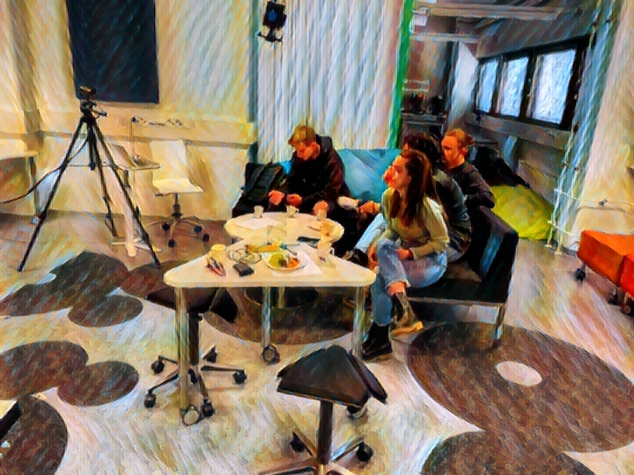
While completing their missions, students had an opportunity to work both online and in the face-to-face mode with the peers from the other countries. The experience of working in international groups led to cross-cultural comparisons, gave the students skills of working with others, and also helped them to see the importance of learning English.
This project makes it easier to create a meaningful connection with different schools in our countries and other countries.
Latvian teacher

Internationalization is important for schools and school teachers. Connections made during the project duration impact the school culture, make teachers more confident, help to develop teachers as professionals and prepare both students and teachers for the challenges of living in multicultural societies and the globalized world.

How can these open schooling models be implemented in local secondary schools without having to change the entire system?

Identifying the barriers
Introducing open schooling models in the current educational reality encounters numerous challenges as the traditional educational systems are not yet fully prepared to accommodate this type of innovation. The research carried out during Mission Based Learning project helped to identify some of those barriers which impede the process of implementing open schooling models.

At the end of the academic year, we always find a lack of time to complete and finish the main ideas of the project to be developed, with more time the results could have been better.
Spanish teacher
The first barrier mentioned by the project teachers concerns running overloaded schedules which require them to stretch their working hours. In the existing teaching arrangements teachers must share their time between their regular teaching and administration activities and working on innovative projects such Mission based Learning. While highly motivated educators, determined to introduce innovations will manage to find time for both, though sometimes at the expense of their personal life, sustainable implementation of open schooling must consider ways of managing people’s time and other resources.
On top of the teaching the regular curriculum teachers had to find time to organize and supervise missions which as essentially students-driven and therefore may go beyond the existing curricula. Accommodating the need to follow the curriculum and, at the same, giving students extensive learning autonomy was a serious challenge for the teachers involved in the project. Insufficient flexibility of the educational system sometimes stood in the way of implementing Mission Based Learning open schooling model.

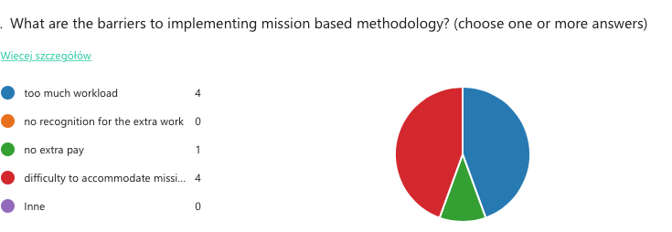
Fig. 1 Barriers to implementing mission based methodology.

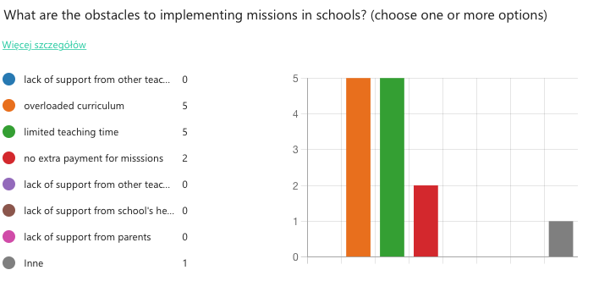
Fig. 2 Obstacles to implementing Mission Based Learning at schools.

Overcoming the barriers
How might these barriers be overcome? Clearly, in order to focus teachers on implementing open schooling, teachers and students need sufficient time resources at their disposal. Therefore (educational) authorities should consider the following:

- including the time spent on supervising missions into the overall individual teacher’s workload or consider a reduction of the other teaching duties/hours,
- giving extra recognition to teachers for the workload put into missions: e.g. vertical or horizontal career growth, extra payment etc.,
- providing more support for schools in terms of organizing missions or providing direct support for students.

One solution which could help to popularize open schooling models would be allotting a specific number of teaching hours to the implementation of this educational strategy. The quality of open schooling projects and teachers’ work would greatly benefit from them having more energy resources which could be spent on supervising open schooling activities. The exact number of hours spent on missions or other types of opens schooling projects might vary according to local needs but this would be a move for all involved teachers.
Teachers-innovators clearly stated that they would like to be provided with some recognition for the extra work they do above their regular duties. While the decisions as to the form of this recognition lies in the hands of school or local authorities, a systemic solution which promotes actions aiming at implementing open schooling methodology could a step in the right direction.
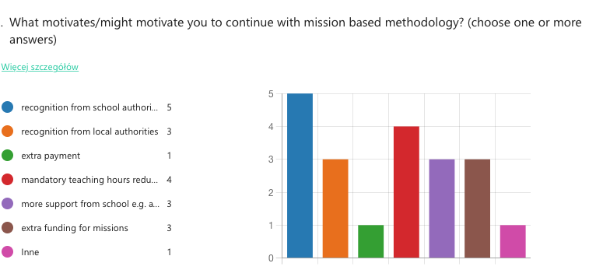
Figure 3. The sources of the teachers’ motivation for implementing mission based methodology

What can you do?
- Include the time spent on open schooling activities in the overall teacher’s workload.
- Consider more flexible curricula – include the option of teaching subject content by means of open schooling methodology.
- Provide teachers with adequate recognition for introducing open schooling models in school practices.
- Consider extra remuneration for teachers if open schooling activities are carried out alongside the regular working hours.

How can educational authorities help schools, teachers and students create local community collaboration?
More experts on specific topics would be very welcome to help teachers deal with certain knowledge or skills we would like our students to acquire.
Spanish teacher

Local educational authorities can use their political clout to facilitate the creation of a network of connections between schools and knowledge centers, businesses or individuals who can support open schooling practices. While during Mission Based Learning project the teachers predominantly used their personal contacts to provide their students with interesting learning opportunities, in the long run, a more sustainable support strategy needs to be found.
One solution would be to establish a formal database of institutions and individual experts willing to work and collaborate with schools. Such a database of contacts, easily available to teachers, would significantly reduce the time and effort necessary to set up local collaboration tasks between school students and local experts. Teachers and students who plan to engage in open schooling practices would be able to access the contacts details of such institutions and use their expertise to inform their educational projects.
The support from local and educational authorities could be provided by facilitating access to these institutions.
Romanian teacher

Another important step towards creating stable and long-term collaboration with the local community would be giving more recognition to the role that students’ parents play in promoting supporting and popularizing the idea of open schooling. Mission Based Learning showcases several projects in which parents played in a key role in terms of facilitating connections between knowledge centers, businesses or other institutions. These examples involve a Spanish mission which featured a visit to the local club that was made possible by one of the students’ parent or a Lithuanian mission revolving around the theme of useful herbs.
Local educational authorities should consider giving parents some form of formal recognition for their valuable contribution to open schooling activities. This recognition could be realized, for example, by developing a badging system whereby schools where parents are particularly supportive could receive a badge awarded by a (local educational) authority body. This, in turn, would help to increase the visibility of a school in a local community. Another incentive could be allocating extra funds for those schools which successfully attract parental support.
Seeking ways to involve parents in open schooling activities has several advantages not only for students and teachers but also for the whole educational and local community. One of such advantage is building a trust relationship between a school and parents who, due to their personal involvement, develop more vested interest in promoting good quality school education. In this way parents become true key stakeholders of the educational process and are better positioned to understand the needs of a particular school and local community.
What can you do?
- Create a ready-to-use-by-schools database of individuals and institutions ready to support open schooling.
- Encourage parental involvement.
- Give tangible recognition to parents for their support to open schooling.

What is the wider benefit for the local educational community from implementing open schooling models and community initiatives?

A local educational community can draw several benefits from implementing open schooling models. These concern:
- educating more autonomous students with good communication skills,
- developing advanced teacher skills,
- creating leaders of innovation,
- encouraging between schools collaboration.

Open schooling practices may lead to students developing a number transversal skills such as good communications skills, a better command of foreign languages, digital skills and many others. These skills help young people to engage in lifelong learning at different stages of their careers. Autonomous, well-educated people contribute to enhancing standards of education at every level. Good quality of secondary school education may result into exerting pressure on tertiary educational level institutions to provide high quality teaching.
Another gain concerns the professional development of teachers. Mission Based Learning teachers admit to improving communication skills, management skills and gaining internationalization perspectives. Working with a diversity of local partners helps teachers adopt fresh perspectives on teaching their subject area.
Due to their disruptive character, open schooling practices have the capacity of creating leaders of positive educational change. These could be teachers and students who will champion innovative practices in a local educational community thus contributing to enhancing the quality of local education.
‘Schools will be supported to make vital contributions to their communities, student projects will meet real needs, they will be presented publicly, and draw upon local expertise and experience.
The school environment will foster collaboration, mentoring, and will provide opportunities for learners to understand and interrogate their place in the world.’
Open schools for open societies, openschool.eu
Disseminating and showcasing the effects of implementing open schooling may lead to creating stronger networks between local schools. Learning together to deal with the challenges of teaching, dealing with the limitations of teaching the national curricula and finding meaningful ways of learning for students can create an added value which may benefit the whole educational community.

What is the wider benefit for the community and the citizens from implementing open schooling models and mission-based learning initiatives? How can all players in the community benefit from schools and students as change agents?
Community collaborations facilitate meaningful relationships and networks thereby preparing students for the real world. There is a shared sense of involvement and accountability in building future 21st-century citizens. –
academic teacher from Finland
Since open schooling provides meaningful learning to the 21st century students, young people have plenty of opportunities to gain more profound knowledge than in the traditional system. Better educated people can turn into more conscious and responsible citizens which every locality needs. This means that young people will become more of aware of the social, environmental or cultural issues that a particular local community has to face.
The themes of the mission are close to the local community, they help to solve problems and raise awareness.
Polish teacher
One important feature of the open schooling model promoted in Mission Based Learning project is a strong focus on student-led research. As this research is meant to be carried out in the local community and in collaboration with the local community, it naturally leads to diagnosing local problems and ways of dealing with them. This is, in turn, can translate into enhancing the quality of living standards in a local area.
Local community members are included in educational process and they can see students being interested in solving local issues.
Latvian teacher

Meaningful relations between students and the local community are, for example, well reflected in the missions implemented by teams of Romanian students. Their project is a good example of a symbiosis between local authorities and the school. The students worked together with the municipal authorities to advertise the local attractions. For this purpose the students designed a website which promotes the city of Craiova, Romania. The advantages of the projects were on both sides: while the authorities benefited from the mission by having students advertise the local attractions, the students learnt more about their home town and developed their digital and communication skills.

How can local educational authorities empower themselves to lead and drive such educational innovation, and how can students co-create the innovation?
Through their work, students have shown that they can be a vector of change in a society with underfunded education, with chronic problems and obsolete teaching methods. These things can be an example of good practice for other schools as they could be a learning model that should be applied more widely by the Ministry of Education and other relevant institutions
Romanian teacher
Showcasing the success of educational enterprises such as project Mission Based Learning can be a driving force spurring local and national educational authorities alike to a bolder and wider implementation of open schooling. Therefore, any actions which advertise the positive effects of open schooling will help local authorities to popularize this learning strategy. Some of the actions that can be taken by local authorities include:

- showcasing success stories during offline and online events,
- collecting evidence of the impact open schooling projects have on school and local communities,
- making students voices more audible – inviting students to talk to others about open schooling,
- using parental and school management’s support for open schooling.

Showcasing success stories of open schooling projects can be done by organizing offline, face-to-face multiplier events and also during online meetings. Whatever the form, it is important that the participants of such events not only passively listen and watch the presentations of good practices but are encouraged to consider ways of implementing similar activities in their own educational environment. This can be achieved through discussions and encouraging schools to draw up plans for integrating open schooling projects into their repertoire of educational activities.
Collection and dissemination of evidence of the positive influence on education that open schooling practices have is another action that local authorities can take in order to empower themselves to drive such innovation. Some evidence collection and dissemination solutions include creating a website especially dedicated to local open schooling initiatives which present students’ learning and or social media accounts run by educational authorities which could showcase such innovative practices.
The evidence must also come in the form of student voices who can convincingly speak of their experiences with open schooling. Students involved in Mission Based Learning reacted enthusiastically to this model of open schooling and so the project intellectual outputs bear testimonies to the overwhelmingly positive impact of missions on the whole school and local communities. Therefore, inviting students to speak at local events or quoting students’ opinions on open schooling is yet another strategy for promoting innovation.
During the project implementation phase we identified the sources of support that teachers used in order to implement missions. It turned out that considerable support came from the schools’ heads, other teachers and parents. Undoubtedly, a maverick teacher will find it difficult to promote educational change. The help from fellow teachers and the school management is a key success factor in implementing open schooling. There is sufficient evidence that educational innovation is most effective when initiated in a bottom-up manner, therefore educational change should start with the involvement of school teachers and school heads. Winning their support for open schooling can become a decisive factor in scaling up open schooling practices.
Parents can also exert pressure to increase and widen the adoption of open schooling models. Once involved in open schooling projects and convinced of their effectiveness parents may be another group of key stakeholders of the educational process who can become an important ally in introducing educational change. Evidence of parental support and their positive role in backing innovation can also lend further arguments in favour of open schooling.

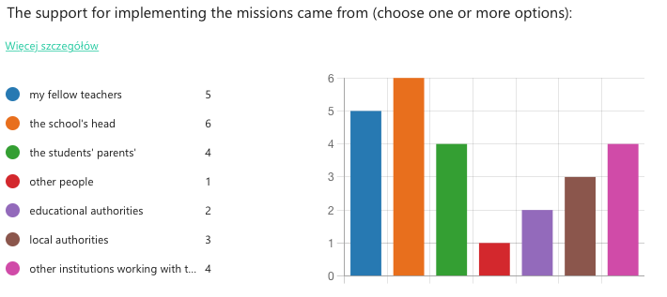
Fig. 4. Sources of support for missions.

Can students co-create innovation?
Yes, because their generation think differently and need different things. They can show policy makers in which direction the change should be implemented.
Latvian teacher
Students indeed can become change agents. As the principle of student agency and leadership lies at the heart of Mission Based Learning project, we demonstrated that young people can identify the issues that impact the well-being of local and not only local communities and are capable of putting forward solutions and taking actions to alleviate the problems.
The project showed that giving students space, time and agency can lead to astounding amounts of student learning on a variety of topics. This positive experience encourages teachers to continue with mission based learning methodology in the future.
Definitely, [mission based methodology] will be a regular basis for my students and a way to improve their language.
Latvian teacher

What can you do?
Showcase good practice examples:
- organize good practices dissemination events for local schools,
- advertise good practices online,
- invite innovators to talk to other teachers,
- invite students to talk to teachers and peers about open schooling projects,
- use evidence of school management and parental support for promoting open schooling.

Letters from students

As this policy paper aims to answer the question: What can local policy makers do for the 21st century young learners?, it seems fitting to conclude it with a presentation of what students have to say of their schooling needs.
During our final project mobility, we asked the participating students to write letters to local or national educational authorities with a view of voicing their educational needs, wishes and concerns (see Appendix below). On the one hand, these letters express the students’ concerns with issues relevant to their specific educational contexts and, on the other, they point to their critical thinking capabilities and maturity. These student voices can be summarized as follows:

- Students need advanced level intense English language education to prepare for international encounters.
- They decent study conditions.
- They postulate investment in schools in terms of providing adequate study spaces, computer and other equipment.
- They need to be given autonomy and want their voices to be heard.

In Appendix we included these powerful messages to local decision makers in their original form.

What can you do?
- Invest in good study conditions: classroom space, equipment,
- Provide good level communication skills training, especially in English, including international experiences,
- Give students space and autonomy: decision making power to students listen to students; voices.

References

European Commission, Science education for responsible citizenship: report to the European Commission of the expert group on science education, Publications Office, 2015, https://data.europa.eu/doi/10.2777/12626

European Commission, Open schooling and collaboration on science education (2022), https://cordis.europa.eu/programme/id/H2020_SwafS-01-2018-2019-2020/pl

Open Schools for Open Societies (n.d.), https://www.openschools.eu

Appendix
